K1A2
Tento týden nás čekají dva texty, jeden lehčí, druhý malinko pokročilejší. Ke každému textu máme úlohy. Pište přímo do tohoto dokumentu, který uložíte jako svoje jméno.
Jedna z úloh je i psaní. Při psaní můžete použít slovník (ne překladač). Psaní budu hodnotit.
- Read the following text:
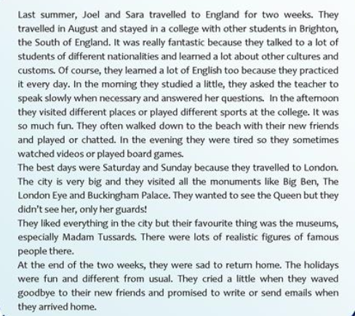¨

2) Write the following in the negative and interrogative.
1. There were many people on the beach.
Neg.
Inter.
2. He enjoyed the trip.
Neg.
Inter.
3. She was in London.
Neg.
Inter.
4. They stayed in a college.
Neg.
Inter.

3) Answer the following questions:
1. What did Joel and Sara do in the afternoon?
2. Did they learn a lot of new things?
3. What did they like the best?
4. What did they visit in the capital?
5. Did they like the museum?
6. What museum did they like the best?
7. Did they see the Queen?
8. Were they happy at the end of the holidays? Explain.
9. What did they promise to do when they arrived home?

4.) And how about you? Write a short paragraph about your best travelling experience. Use at least 90 words. I will grade it! Use the past tense.

5) Read another text:

Amazing adventurers
Do you ever dream about climbing Mount Everest or visiting Antarctica? If so, you’re not alone. Every year, thousands of people try to climb the world’s highest mountains or walk across continents. Let’s take a look at some of the 21st century’s greatest adventurers.

Amazon adventurer
Ed Stafford from the UK is the first person to walk along the Amazon River from the mountains of Peru to the mouth of the river in Brazil. His amazing journey took two years and four months. There are many dangerous animals in the rainforest, like snakes and crocodiles, but Ed was lucky; he was only bitten by ants and mosquitoes. On his trip, Ed had to find fruit and nuts or catch fish each morning. Sometimes food was hard to find and Ed was often tired and hungry.
Technology was very important for Ed. He used a radio to ask the people of the rainforest for food and help. Many people came to meet him and guide him through the rainforest. While he walked, Ed wrote a blog to tell the world about climate change and destruction of the rainforest.

A mountain climber
Did you know that more than 4,000 people have climbed Everest? Gerlinde Kaltenbrunner from Austria is one of them. She is one of the world’s greatest climbers and has climbed all the world’s mountains over 8,000 metres. It’s very difficult to climb in cold weather and storms, but Gerlinde loves it. She started climbing as a teenager in the mountains near her home. When she left school she became a nurse but always went climbing in her free time. Now she spends her time climbing and helping a charity for poor children in Nepal.

More than one adventure
Some adventurers are always looking for a new challenge. Meagan McGrath from Canada has climbed mountains, ridden a bike across Canada and run races in the desert. But her most incredible journey was a skiing trip to the South Pole. As she skied, Meagan pulled a sledge with a tent and all her food. She skied through terrible storms and freezing temperatures for forty days till she arrived at the South Pole.
Erik Weihenmayer from the United States has climbed mountains and ridden a bike through deserts. Amazingly, Erik is blind and he wants other blind people to have active lives too. He has taken groups of young blind people climbing in Nepal.

Where next?
Technology is a big help for adventurers but the world is still a dangerous place and it’s very important to prepare well. If you dream of being an adventurer, there will always be continents to walk across and mountains to climb!

6) Complete the table with irregular verbs from the text:
Take |  | Come
Have |  | Write
To be |  | Become
7) Are the sentences true or false? Write T or F to each sentence.
1) Ed Stafford walked along the Amazon from Brazil to the mountains of Peru
2) Ed's walk along the Amazon took 28 months.
3)Ed was bitten by a snake in the rainforest.
4 Gerlinde Kaltenbrunner climbed for the first time when she was a nurse.
5) Gerlinde Kaltenbrunner helps a charity for blind people.
6) Meagan McGrath had bad weather on her skiing trip to the South Pole.

8) Complete one word or a name.

- Ed Stafford was often tired because he didn’t have enough __________.
- Ed Stafford wrote a blog about climate change __________ his walk.
- __________ hasn’t travelled in cold weather.
- Gerlinde Kaltenbrunner is from __________.
- __________ has ridden a bike across Canada.
- Erik Weihenmayer has helped blind people to __________.

