K3A2:
William Shakespeare
- Please watch the video:
https://www.youtube.com/watch?v=j1kf1ZGON-I

- Open the google form worsheet:
https://docs.google.com/forms/d/e/1FAIpQLScSN_MNVTMAYt3GBpO3Gnuh3ntedzYdLctYis9w3DQk5Hxr-g/viewform?usp=sf_link

and fill it in.

You need to make questions and answer them based on the video you will watch.

If you get everything correct (including the correctly made questions), you have a chance for a small A! What a motivation, eh?

- Interested in how did the Globe work and look like? Take a look here:
https://www.dkfindout.com/uk/music-art-and-literature/shakespeares-globe/

Make a quiz below!

- We talked about idioms. Remember? Here you have a list of some them. How many do you know? (idioms budeme dělat ve čtvrtek)
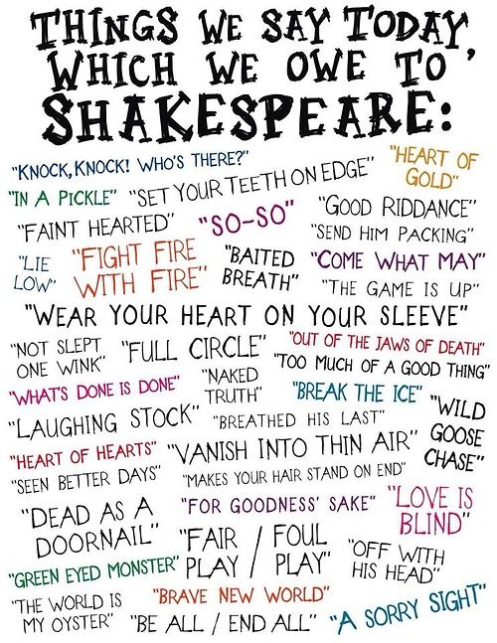
- My favourite one is „to be in a pickle“. Here you will find a quite funny video and tasks you can do after watching. Enjoy!

https://www.bbc.co.uk/learningenglish/english/course/shakespeare/unit-1/session-1

