K4A2
This week we are going to talk about an American writer Edgar Allan Poe.
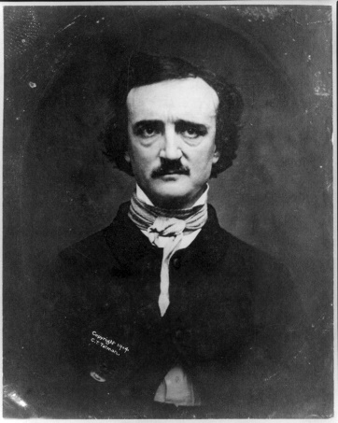
We will talk about his life and later about his work as well.
- Please, watch this mini biography video:
https://www.youtube.com/watch?v=x-387NMCR6w
and complete the missing words
Complete: full-time, made a living, suspense, the father of detective stories, legacy, 20, 13, 40, breakthrough, bizzare, secretely, enrolled, detective fiction, January 19th, literary critic
The worksheet you will find here:
https://docs.google.com/forms/d/e/1FAIpQLSf1RdGm16bEaM9JrNKkaKiMAr2S6OVcAMBf8kDtPUfn91sgew/viewform?usp=sf_link

- Now, let’s watch a short movie based on his story! The animation is a bit old, but I guess that you will enjoy the atmosphere! I recommend it watch it home alone when it’s dark
https://www.youtube.com/watch?v=kkXzGDcT46g
Answer these questions:
- What is a relationship between narrator and Roderick Usher?
- Why did the narrator arrive to the house of Roderick Usher?
- Who is Madeline?
- How does Roderick feel?
- True or false? Roderick and Madeline are the only remaining members of the Usher family.
- What happened to Madeline?
- What happened to Roderick and to the house at the end of a story?
- Bonus question: Did you like the story? Do you think there is any hidden message behind this story? Is it really about a ghost?

- How about a cup of tea (or maybe something stronger), sit at your favourite chair and listen the beautiful and haunting voice of Christopher Lee (you know him as Saruman from the LotR)?
https://www.youtube.com/watch?v=BefliMlEzZ8

- I strongly recommend to listen (yes, another dramatic reading) this: https://www.youtube.com/watch?v=KnHFMAxACnM
while reading this: https://poestories.com/read/telltaleheart
This reading is actually very DISTURBING, but I really like it and and I think you will practise your listening and reading skills!
Enjoy

