K4A2
This week we are going to talk about another important writer Oscar Wilde. During our lessons we will focus on his life and on his work. Here we will talk mostly about his work.
- Read and listen one of his stories here:
https://www.youtube.com/watch?v=w-7e1gwwqdY&feature=emb_logo
and answer these questions:

- What did people say about the statue of the Happy Prince at the beginning of the story?
- Why did the swallow stay behind?
- Where did the swallow spend the first night in the city? Why did he like it?
- Why did the Happy Prince cry?
- What did the Happy Prince ask the swallow to do with 3 jewels?
- Why did the swallow decide to stay with the Happy Prince forever?
- What happened to the gold on the Prince’s armour?
- Why did the swallow die? What did he do just before he died?
- What did the people say about the statue of Happy Prince at the end of the story? What did they do with it?
- What did the angel bring to God and why?

2) Further tasks:
- What is the past tense of the following verbs?:
fly shake sit feel hear write come begin fall asleep think bring find sleep grow bright/cold wear take out see

- Rewrite in a few sentences the plot using the following vocabulary:
jewel armour fever command blind poor admire column thirsty ugliness misery suffer sad drop tear cry

Bonus video: Probably the most famous work by Oscar Wilde is The Picture of Dorian Gray. Here you can find the video summarizing the plot:

https://www.youtube.com/watch?v=27-3OVRYgQI

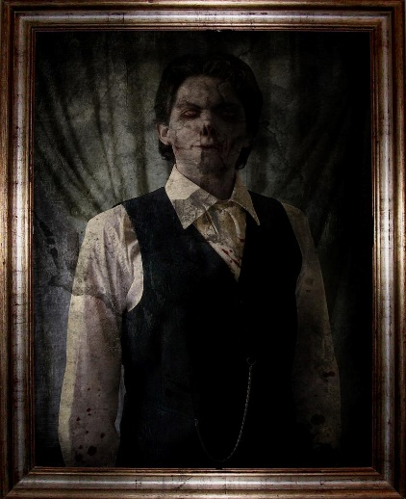
Tato fotka od autora Neznámý autor s licencí CC BY-NC-ND

