K2A2
Hello again!
This week we are going to practise your listening skills. You will do 3 LISTENING TASKS and ONE TASK where you need to translate a few questions. One listening might be too easy for you, another one maybe a bit difficult, but I believe in you. Please, no cheating. These listening tasks are for practising for your exams.
(tento týden budeme dělat poslechy a jedno cvičení na překlad. Pište přímo do tohoto dokumentu. Pozor, dokument má dvě strany)
PART ONE
- Listen the podcast and decide whether the sentences are true, false or it is not said.
You will hear James talking about his girfriend with Mia.

https://www.bridge-online.cz/wp-content/uploads/Love-Language.mp3

- James is sure that his girlfriend doesn’t love him anymore.
- The girlfriend of James spoke to Mia before.
- James has problems to say: „I love you“ to his girlfriend.
- James buys a lot of gifts to his girlfriend.
- James and his girlfriend are not living together.
- Mia has a bad experience with her last boyfriend.

- Listen again and briefly answer:

- What is the main reason that James is complaing about?
- What exactly is James’s girlfried worried about?
- In which ways does James usually show his feelings?
- What does James’s girlfriend miss the most in their relationship?
- What is Mia’s advice?

PART TWO
LISTENING: Open this page:
https://www.bridge-online.cz/wp-content/uploads/2016/09/listening.pdf
You will hear people talking in different situations. Choose the best picture.
Question 1: https://www.bridge-online.cz/wp-content/uploads/2016/09/question1.mp3
Question 2: https://www.bridge-online.cz/wp-content/uploads/2016/09/question2.mp3
Question 3: https://www.bridge-online.cz/wp-content/uploads/2016/09/question3.mp3
Question 4: https://www.bridge-online.cz/wp-content/uploads/2016/09/question4.mp3
Question 5: https://www.bridge-online.cz/wp-content/uploads/2016/09/question5.mp3

The answers complete here into this chart:
1 | 2 | 3 | 4 | 5

PART 3
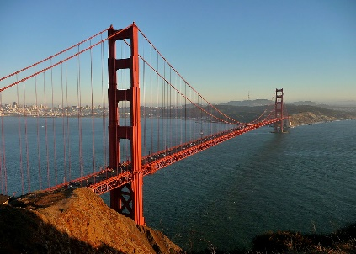
You will hear a listening about the famous bridge in the USA.

https://www.bridge-online.cz/wp-content/uploads/2016/09/14-2.mp3

Complete the word/words:

- San Francisco is a ______________name for _____________________. It was founded in _______________________by________________________.
- The Channel between the Pacific Ocean and San Francisco Bay is__________wide____________long.
- The construction of the bridge began_______________________
- There is a team of_______________painters who reaply the paint on the bridge.
- Until___________________the Golden Gate Bridge was the longest suspension bridge in the world. Now the longest suspension bridge is ______________________________ in New York City.

Listen again and briefly answer:
- Why were many experts sceptical about building this bridge?
- The bridge was completed later that it had been scheduled. True or false?
- Why was it closed and how many times?
- What is the official color of the bridge? Why did the choose this color?

PART 4
Translate these questions:

- Kolik lidí přišlo na ten večírek?
- Komu píšeš?
- Na co jsi se včera díval v televizi?
- Jak často navštěvuješ svého nejlepšího kamaráda?
- Jako hudbu obvykle posloucháš?
- Co hodláš dělat zítra po práci?
- S kým jsi jel do té Itálie?

