The UK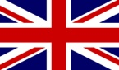

- Location
- Parts, symbols
- Political system
- People, languages, nationalities
- Geography (landscape, climate etc.)
- Places of interest (natural beauty, monuments, sights etc.)
- Other

- LOCATION: It is an island country located on the northwestern coast of mainland Europe.
- The United Kingdom comprises the whole of the island of Great Britain and the northern part of the island of Ireland.
- ENGLISH CHANNEL: a body of water that separates Southern England from Northern France.
- THE NORTH SEA: on the east coast of the UK
- THE IRISH SEA: on the west coast of the UK

- PARTS: 4 countries: England, Wales, Scotland, Northern Ireland

- SYMBOLS: each country has its own capital (England – London, Wales – Cardiff, Scotland – Edinburg, N. Ireland – Belfast), its own flag and flower as symbol (England – rose, Wales – Daffodil, Scotland – thistle, N. Ireland – shamrock)

- BRITISH FLAG – UNION JACK

- POLITICAL SYSTEM: parliamentary democracy under a constitutional monarchy in which the monarch is the head of state
- Prime Minister of the United Kingdom is the head of government.
- Executive power is represented by British government.
- Legislative power is divided in the two chambers of the Parliament of the United Kingdom, the House of Commons and the House of Lords ( as well as in the Scottish Parliament and Welsh and Northern Ireland assemblies.)
- The UK political system is a multi-party system. Since the 1920s, the two dominant parties have been the Conservative Party and the Labour Party.

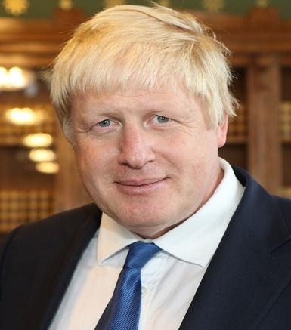 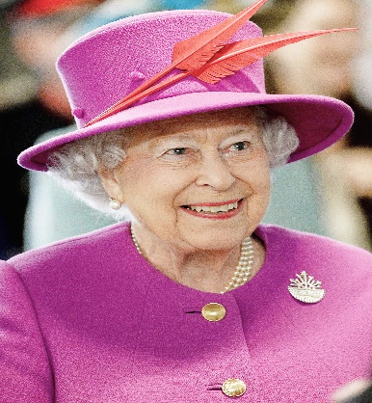 Prime minister Boris Johnson and the Queen – Elizabeth II.
Boris Johnson – the current prime minister
Tato fotka od autora Neznámý autor s licencí CC BY-SA

- PEOPLE - 66.02 million (2017)
- indigenous British people have origins from the various ethnic groups (the Celts, Romans, Anglo-Saxons, Norse and the Normans)
- immigration: mostly due to colonies, Liverpool has the oldest Black population in the country (the 1730s )
- the oldest Chinese community in Europe (19th century)
- Immigration from other countries: India, Pakistan, Nigeria, Poland…
- Ethnic diversity (30.4% of London's population estimaned as to be non-white in 2005

- LANGUAGES: Official language: English (many varieties of accents)
- Another languages amongst minorities: Punjabi, Hindi, Bengali, Polish…
- 4 Celtic languages: Welsh, Irish, Scottish Gaelic and Cornish (recognised as regional or minority languages)

- GEOGRAPHY, CLIMATE, LANDSCAPE: temperate climate (plentiful rainfall all year round)
- Atlantic currents, warmed by the Gulf Stream, bring mild winters
- Summers are warmest in the south-east of England, coolest in the north
- The UK covers an area of 244,820 sq km (only three times bigger than CZ)
- The physical geography is varied with the highest mountains in Wales and Scotland (Ben Nevis 1,343m), there are many lakes in the north of the country, the most famous is Loch Ness, but the biggest is Lough Neagh (located in N. Ireland).
- The eastern and southern parts of England are lower.
- Division – higlands and lowlands
- The most famour river is Thames (flow throught London), but the longest is a river Severn

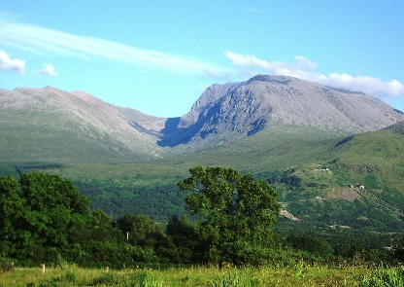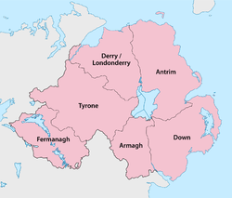
BEN NEVIS – THE HIGHEST PEAK
The largest lake is in the Northern Ireland

- PLACES OF INTEREST

- Cities: The capital is London
- London Eye, Tower Bridge, Big Ben, Tower of London, Hyde Park, Westminster Abbey, Palace of Westmisnter, Buckingham Palace, Picadilly Circus, Oxford Street, Natural History Museum
- More cities: Oxford, Brighton, Liverpool, Birmingham, York, Manchester, Leeds, Glasgow…

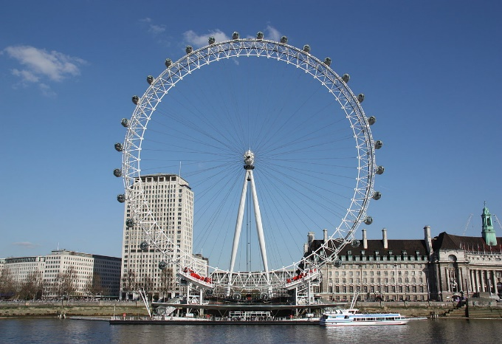
London Eye

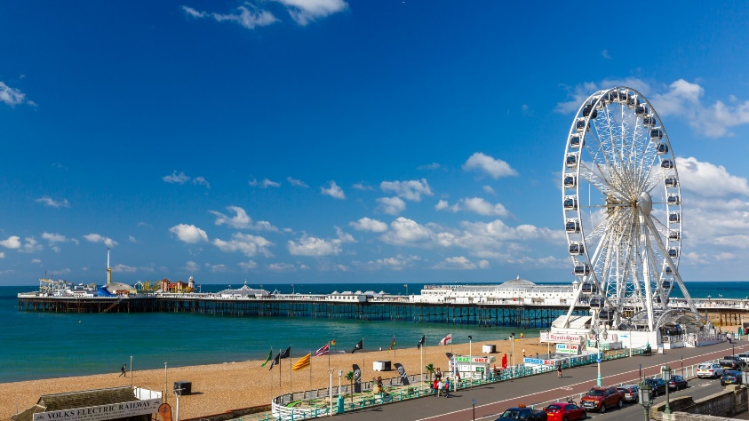 Brigton – a city with a famous beach

- Another places of interests:
- University cities Oxford and Cambridge

- Statford-upon-Avon: the birthplace of Shakespeare

- Stonehenge: a prehistoric monument in England

- Lake District: mountainous region in North West England. A popular holiday destination, it is famous for its lakes, forests and mountains

